DATA MINING REPORT

Name: ZAIGHUM JAWAD ASLAM

D03000118

**Morphological Classification of Extragalactic Radio Sources Using Gradient Boosting Methods**

# 1. Introduction

The field of radio astronomy is experiencing a rapid increase in data generation with the deployment of advanced radio telescopes. One of the key challenges in this domain is the automated classification of extragalactic radio sources according to their structural characteristics. Recent advancements in the morphological classification of extragalactic radio sources have focused on classifiers utilizing convolutional neural networks. In contrast, this study introduces gradient boosting techniques combined with principal component analysis, offering a more data-efficient alternative to neural network-based approaches. A three-class classification problem is considered in this work based on the three main Fanaroff-Riley classes: class 0, class I, and class II, using radio sources from the Best-Heckman sample. In this project, we explore the morphological classification of extragalactic radio sources using both deep learning (CNN) and traditional machine learning (XGBoost) techniques. The dataset comprises radio galaxy images categorized into three classes: FR0, FRI, and FRII. The goal is to classify these images accurately and analyze their structure using advanced data mining and image processing techniques.

Radio observatories, including the upcoming Square Kilometre Array (SKA), are set to enhance our comprehension of the universe's fundamental processes. These observatories will produce data at a scale of hundreds of terabits per second. Given the sheer volume of images generated, manual classification is not practical, necessitating the development of alternative approaches.

Extragalactic radio sources can be categorized into various groups based on their distinct visual characteristics. Upcoming radio observatories, such as the Square Kilometre Array (SKA), are poised to significantly advance our understanding of the fundamental phenomena governing the universe. These observatories are expected to generate data at rates reaching hundreds of terabits per second. Due to the immense volume of images produced, manual classification is not feasible, highlighting the need for automated solutions.

# 2. Dataset Overview

The dataset consists of 13,140 labeled images, each representing a radio galaxy from one of the three morphological categories: FR0, FRI, and FRII. These images are sourced from radio astronomy surveys designed to classify the structural differences in extragalactic radio sources. Each image is sized at 300x300 pixels in grayscale format.

Classes:

1. FR0 (Fanaroff-Riley Class 0): Characterized by weak or absent radio jets, this class is typically identified by compact, symmetric morphology in the radio emission.
2. FRI (Fanaroff-Riley Class I): These galaxies exhibit asymmetrical radio jets, where the emission from the jet is brighter on one side than the other. This class is often associated with smaller galaxies or those in denser environments.
3. FRII (Fanaroff-Riley Class II): This class shows highly asymmetric radio jets with a clear difference in brightness, especially in the lobe regions far from the galactic nucleus. FRII galaxies often represent more powerful or active radio sources.

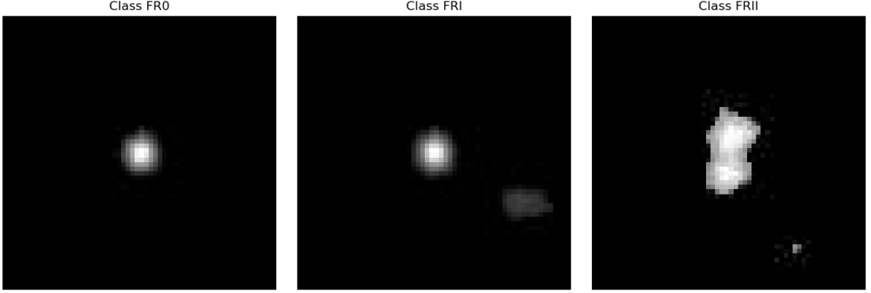

Figure 1: Sample Images of Dataset

Initial Challenges:

While working with this dataset, several inherent challenges were identified:

1. Imbalanced Dataset:

The distribution of images across the classes is imbalanced. This could lead to bias in model training, where the model might perform well on the majority class (FR0), while underperforming on underrepresented classes (FRI and FRII). Such class imbalance may also affect evaluation metrics like recall and F1-score. Various techniques like oversampling, undersampling, or class weights were considered to mitigate this issue.

1. Varying Image Quality:

The dataset consists of images collected from diverse astronomical surveys. This implies that the images come from various sources with inconsistent quality. Some images exhibit blurring, noise, or artifacts, which can lead to misclassifications. Data preprocessing methods like cropping, normalization, and image augmentation were employed to enhance image quality and robustness.

1. Presence of Noise and Blank Images:

A significant number of images in the dataset contained high noise levels or blank images with little to no discernible features. These could be images with too little contrast or completely black or white regions. Removing or filtering out these images was essential to ensure cleaner data for training. A simple thresholding technique based on pixel intensity values was used to eliminate these "useless" images.

Results:



Figure 2: Images Filtering

1. Class Distribution:

Upon analysis, it was found that the dataset contained 6066 FR0 images, 5008 FRI images, and 2066 FRII images. The class imbalance was acknowledged and addressed through techniques like oversampling and class weights adjustment in machine learning models. This helps the model focus more on underrepresented classes during training.

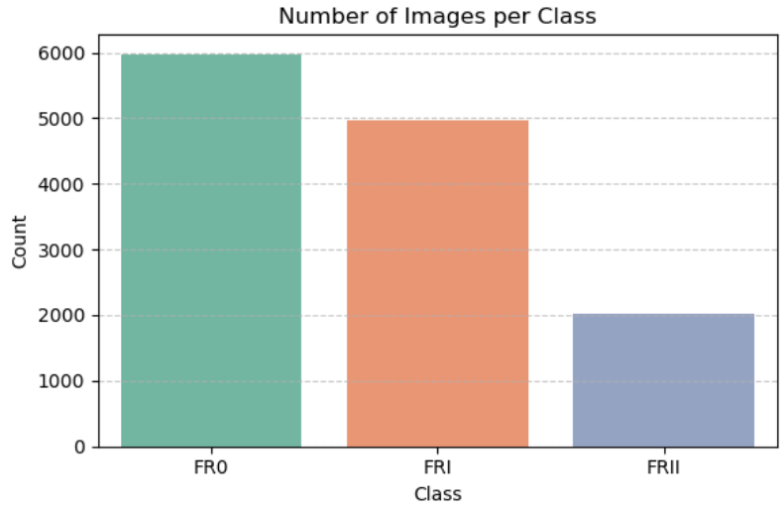

Figure 3: Class Distribution of Dataset

1. Preprocessing Tasks:

Ndung’u et al. (2023) found that preprocessing, including cropping and image alignment, was crucial in extracting relevant features from noisy datasets of astronomical images for better performance in machine learning models. They emphasize that proper data cleaning is critical in domains like astronomical surveys, where data quality can vary.

# 3. Data Preparation

## Loading and Structuring

1. All images were loaded from respective directories. Using python code to locate proper directory to load all the dataset images and then proceeding.
2. Labels were encoded as 0 (FR0), 1 (FRI), 2 (FRII).

## Cropping and Cleaning

After loading the radio galaxy images, each with a resolution of 300×300 pixels, a focused preprocessing step was applied to isolate the most relevant structural features for classification. Specifically, a center-cropping operation was performed to extract a 60×60 patch from the middle of each image. This was done under the assumption that the morphological characteristics central to the galaxy (e.g., jets, lobes, and cores) are typically found in the center region and thus carry the most discriminative features. Following cropping, a cleaning process was implemented to remove low-content or blank images that might degrade model performance. Images with a maximum pixel intensity below a certain threshold (set at 5) were identified as non-informative and were filtered out from the dataset. This cleaning phase ensured that the retained samples were both structurally meaningful and useful for subsequent learning tasks.

## Normalization

To prepare the image data for efficient model training and to ensure numerical stability across computations, normalization was performed on all pixel values. Since the original images were in grayscale, pixel values ranged from 0 to 255. These values were scaled to fall within the [0, 1] range by dividing each pixel by 255. This step is crucial in deep learning pipelines as it brings all input features to a similar scale, accelerating convergence during training and preventing gradients from vanishing or exploding. Normalization also facilitates more consistent feature learning, especially in convolutional neural networks (CNNs), which are sensitive to the range and distribution of input data.

# 4. Exploratory Data Analysis & Visualization

## 4.1 Sample Visualization

To visually verify the integrity and structure of the dataset, random sample images were displayed for each class both before and after cropping. This step provided a qualitative understanding of the spatial distribution of morphological features across FR0, FRI, and FRII radio sources. Initially, the full-resolution grayscale images (300×300 pixels) were center-cropped to a 60×60 region to focus on the most information-dense area, typically where radio jets and core structures are visible. By plotting original and cropped image pairs side-by-side, it became evident that cropping retained the core morphological traits while eliminating redundant background noise. This visual confirmation validated the preprocessing decision and helped ensure that essential features were preserved for model training. The visualization also reinforced class consistency and served as an early-stage sanity check before progressing to further data transformations.

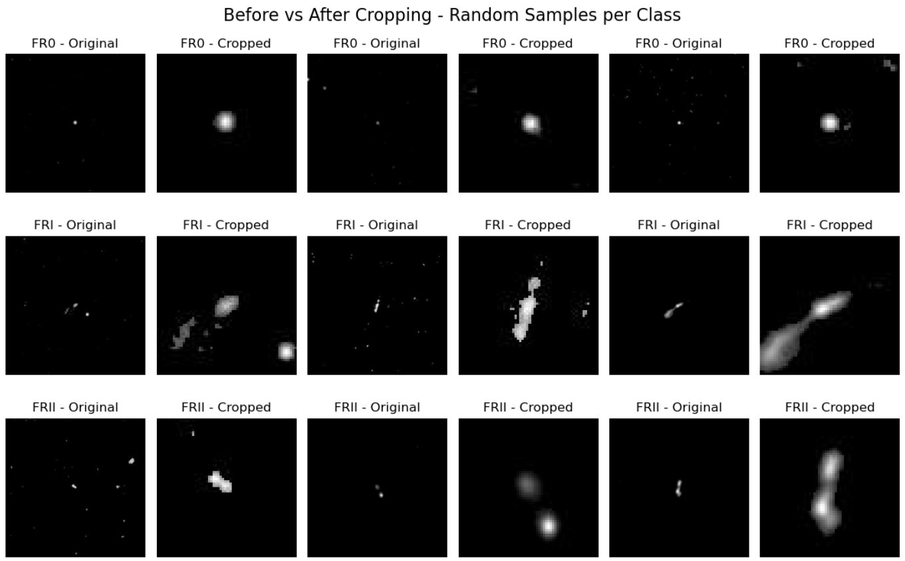

## 4.2 Data Augmentation

In this project, data augmentation was used to tackle the challenge of class imbalance in the dataset. The dataset originally had unequal representation among the three classes: FR0, FRI, and FRII, with FR0 images being the most abundant and FRI images being relatively underrepresented. To mitigate this, random transformations were applied to artificially increase the number of images in the underrepresented classes (FRI and FRII) to ensure a more balanced dataset for model training.

The main augmentation techniques used were rotation, translation (shifting), zoom, and flipping. These techniques aimed to simulate variations that the model might encounter in real-world data, making the model more robust. Specifically, rotation was applied by randomly rotating the images within a 30-degree range. This ensured that the model became invariant to the orientation of the radio galaxy images, as these might not always appear at the same angle in real-world scenarios. Width and height shifts (translation) were applied by randomly shifting the images horizontally and vertically by up to 20% of the image dimensions. This addressed any positional variations in the galaxies, where they might appear off-center or shifted.

To ensure effective training and unbiased learning, it was essential to address the class imbalance present in the original dataset. Initially, a significant discrepancy was observed: the number of FR0 images substantially exceeded those of FRI and FRII. This imbalance could lead to a model biased toward the dominant class, degrading its generalization ability for minority classes. To correct this, data augmentation techniques were employed selectively on FRI and FRII classes. Using ImageDataGenerator, we synthetically increased the diversity of underrepresented classes by applying controlled random transformations such as rotations (up to 30°), width and height shifts (20%), zooming, shearing, and horizontal flipping. These transformations maintained the semantic integrity of the images while introducing variability, helping the model learn robust features. Specifically, 4,000 new samples were generated for FRII and 1,000 for FRI, bringing their counts closer to the abundant FR0 class. After merging the augmented samples with the original filtered dataset, the final class distribution was effectively balanced, enabling fair training and improved model performance.

The goal of applying these random transformations was not only to balance the dataset but also to enhance the model's ability to generalize across various possible variations that might be encountered during testing. By augmenting the data, the model became less likely to memorize specific features of the images (overfitting), and instead, it learned the underlying patterns that distinguish the classes, making it more robust and better at predicting unseen images.

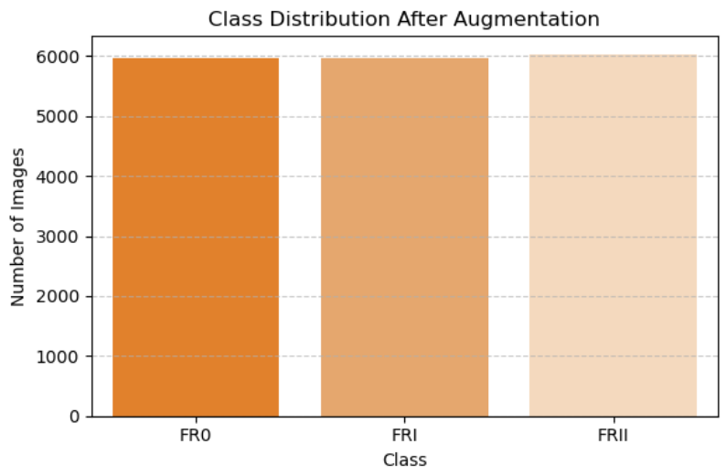

Figure 4: Class Distribution After Augmentation



Figure 5: Final Augmentation Data

## 4.2 Feature Extraction

### 4.2.1 Train-Test Split

To evaluate the model’s generalization ability, the complete dataset consisting of filtered and augmented images was divided into training and testing subsets using an 80:20 ratio. A stratified split strategy was applied to ensure that each of the three classes (FR0, FRI, FRII) was proportionally represented in both subsets. This approach helped preserve the class balance achieved during augmentation and prevented biased evaluation. The resulting split formed a well-distributed and representative dataset, with clearly defined labels aligned with each image for subsequent model training and validation.

### 4.2.2 ResNet-50

To generate high-level, abstract features from the radio galaxy images, the ResNet50 convolutional neural network pre-trained on ImageNet was employed as a feature extractor. The final fully connected layer was removed, and the output of the penultimate layer (a 2048-dimensional vector) was used as the feature representation for each image. Because ResNet50 requires 3-channel RGB images of size 224×224, a transformation pipeline was constructed to resize grayscale images, convert them into 3-channel format, and normalize them using standard ImageNet mean and standard deviation values. Images were processed using a GPU-enabled PyTorch pipeline for efficient computation. This deep feature extraction provided semantically rich embeddings for each image, which were then used for downstream classification tasks using traditional machine learning models like XGBoost.



Figure 6: Features Extraction (ResNet50)

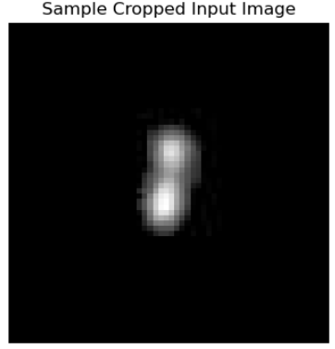

Figure 7: ResNet 50 Sample Image

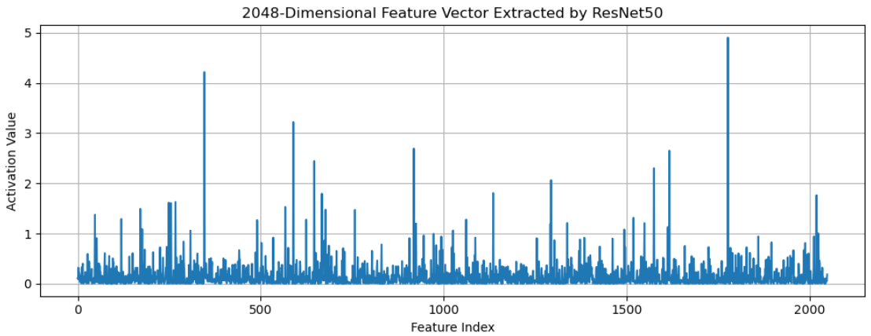

Figure 8: 2048D Features Extraction Using ResNet50

To understand how deep learning models interpret radio galaxy morphology, we visualized the 2048-dimensional feature vector extracted by the pretrained ResNet50 model. After cropping the galaxy images to 60×60 grayscale, they were resized to 224×224 and converted to 3-channel inputs to match ResNet50’s input requirements. Upon passing a single image through the ResNet50 feature extractor (with the classification head removed), we obtained a 2048-element feature vector that serves as a high-dimensional embedding or "semantic fingerprint" of the galaxy.

In the resulting plot, the x-axis represents feature indices (0 to 2047), and the y-axis indicates the activation values for each feature. High peaks suggest strong activation of specific features, meaning the network detected certain edge-like or structural patterns in the image. Flat regions or values near zero imply that those features were not triggered by the image. This feature representation encodes the spatial and morphological structure of the galaxy in a way that is highly informative for downstream classification tasks. These vectors were later used as input to an XGBoost classifier, demonstrating how deep learning can efficiently extract compact, meaningful features from complex visual data.

## 4.2 PCA-Analysis

To gain insights into the structure of the extracted deep features, Principal Component Analysis (PCA) on the 2048-dimensional vectors was obtained from ResNet50. Before applying PCA, the features were standardized using StandardScaler to ensure each feature contributed equally. We first reduced the dimensions to 50 components to preserve variance, and then further projected the features into 2D space for visualization. The scatter plot displays the distribution of training images across the first two principal components (PC1 and PC2), colored by their class labels. This projection revealed partial separability between FR0, FRI, and FRII images, indicating that meaningful morphological variance had been captured.

In parallel, we explored the raw pixel data through flattening, converting each 60×60 grayscale image into a 3600-dimensional vector. This enabled a class-wise correlation analysis, examining how pixel intensities co-vary across classes. These flattened vectors also served as the foundation for pixel-wise statistical analysis (e.g., mean, median, symmetry), helping to validate and contrast the information learned by deep models versus raw pixel distributions.

## 4.3 Mean-Median Analysis of Pixel Intensities

To examine the underlying structural patterns of the three radio galaxy classes (FR0, FRI, FRII), a pixel-level statistical analysis was conducted. Each 60×60 grayscale image was flattened into a 1D vector of 3,600 pixel intensity values. The mean and median intensity values were then calculated across all samples within each class and visualized.

The plots reveal distinct intensity profiles:

* FR0 displays a prominent central peak in both the mean and median distributions, indicating consistent and concentrated emission structures. This supports the known morphology of FR0 sources, which typically lack extended lobes.
* FRI exhibits broader peaks and greater variability in intensity values, reflecting the presence of moderately extended radio lobes. The variability suggests more diverse morphologies within this class.
* FRII shows the most dispersed intensity distribution, especially in the mean curve, which is flatter and wider. This aligns with the structural characteristics of FRII galaxies, where energy is spread across larger, more diffuse lobe structures.

These findings highlight clear pixel-level differences among the classes and support the separability observed through feature extraction and modeling. The visual analysis also reinforces the morphological distinctions without relying solely on complex deep learning interpretations.

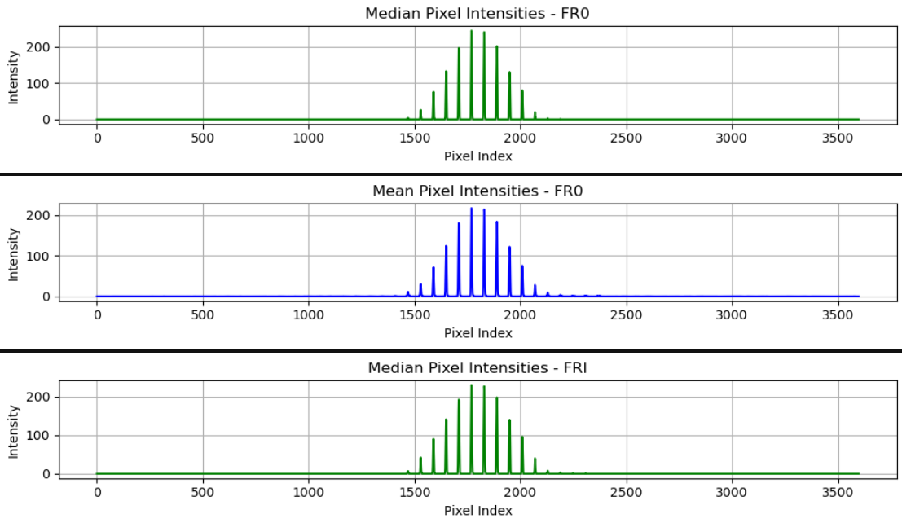

Figure 9: Pixel Intensities (FR0)

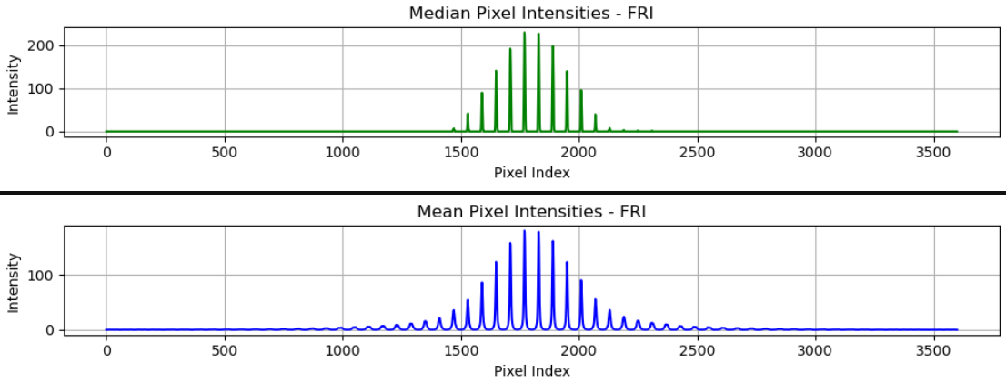

Figure 10: Pixel Intensities (FR1)

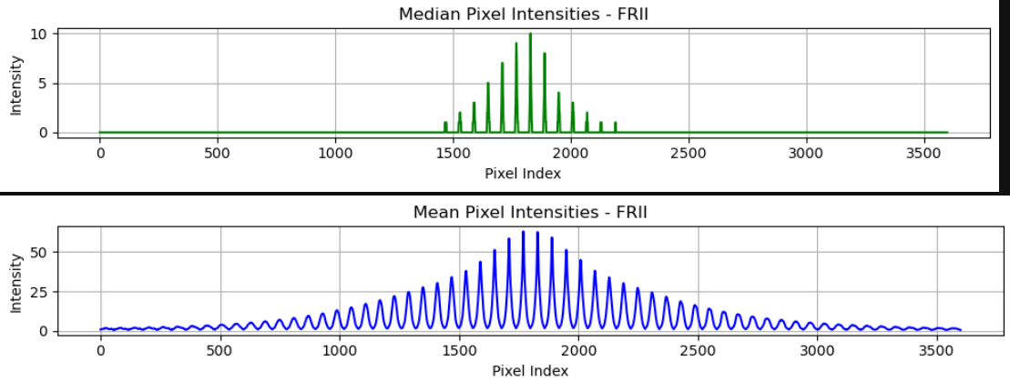

Figure 11: Pixel Intensities (FRII)

## 4.4 Correlation Matrix

To further explore internal structural consistency within FR0 galaxy images, a pixel-wise correlation matrix was computed using the flattened representations of all FR0 samples. Each 60×60 image was reshaped into a 1D array of 3,600 pixel values, and the Pearson correlation coefficient was calculated between every pair of pixel indices across all FR0 images.

The heatmap above illustrates the result. The strong red diagonal line indicates high positive correlation along the diagonal, meaning that individual pixels are most strongly correlated with themselves — as expected. However, the presence of subtle off-diagonal red streaks and patterns suggests that certain spatial pixel regions consistently co-activate, likely representing stable and recurring emission structures typical of FR0 morphology.

This pattern indicates that FR0 sources have a well-defined and compact morphology with low variability across the dataset. Unlike more diffuse classes like FRII, FR0 galaxies show a consistent structure, reinforcing the compact-core nature observed in astrophysical studies.

The correlation matrix helps confirm that the features used for classification in later stages capture meaningful spatial dependencies and not just noise or randomness.

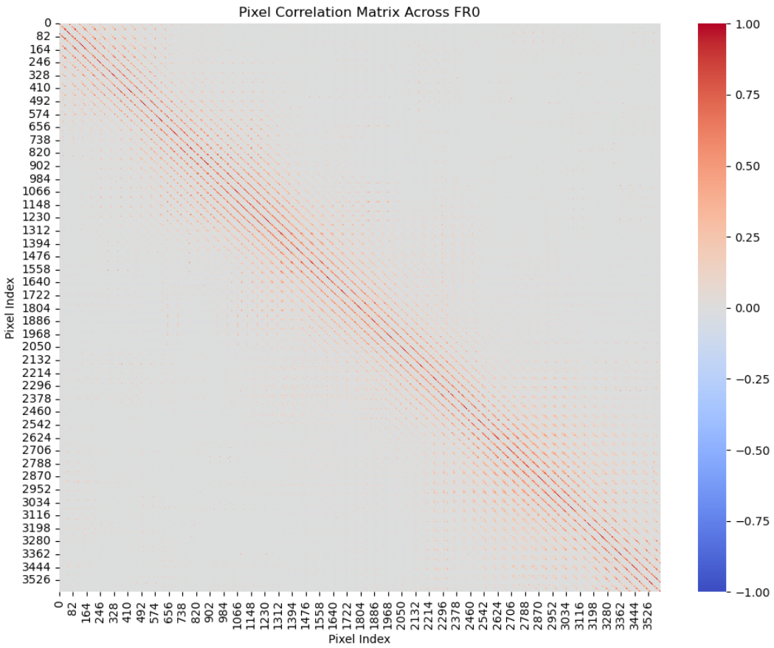

Figure 12: Pixelwise Correlation Matrix (FR0)

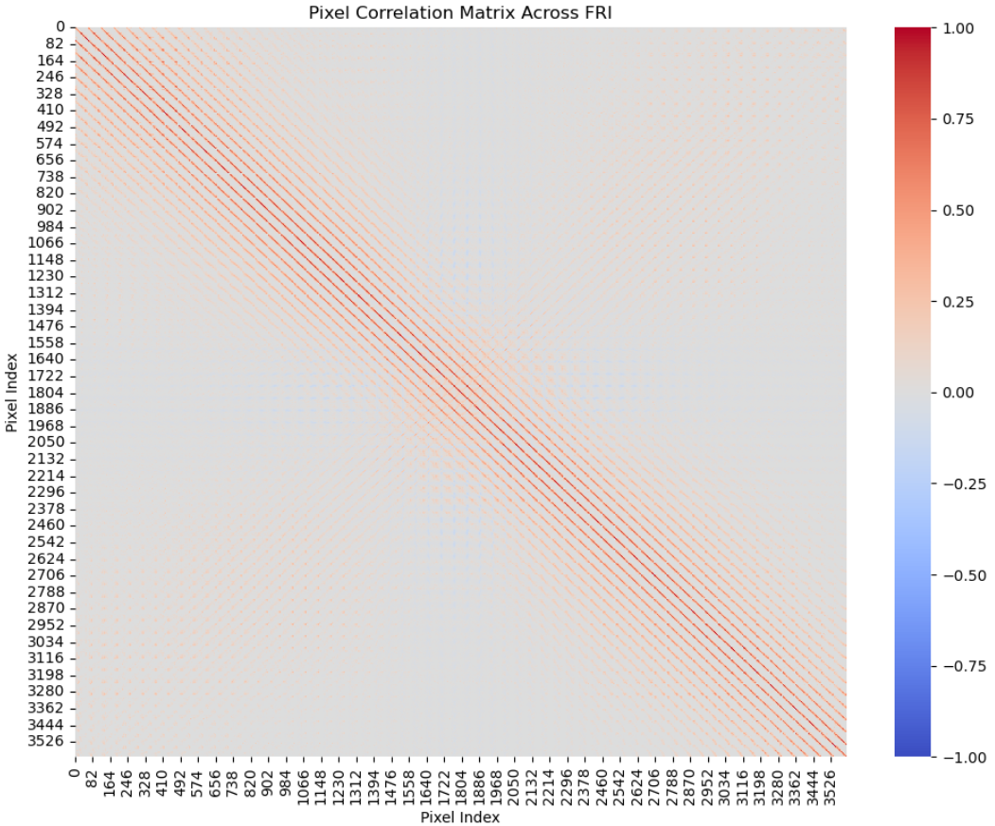

Figure 13: Pixelwise Correlation Matrix (FRI)

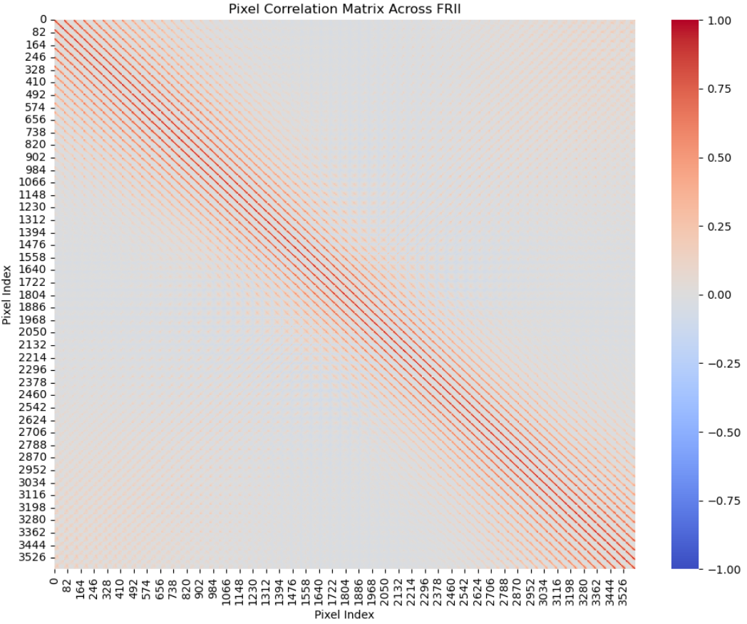

Figure 14: Pixelwise Correlation Matrix (FRII)

## 4.3 Sobel Edge Detection

To better understand the structural differences between the three classes of radio galaxies (FR0, FRI, and FRII), Sobel edge detection was applied to sample images from each category. Sobel filters are used to detect edges by emphasizing areas of high spatial frequency which correspond to object boundaries. This technique is particularly useful in radio astronomy where morphological traits are critical for classification.

For each class, three representative images were selected. These original grayscale images were passed through the Sobel operator, producing corresponding edge maps that highlight the intensity gradients. As seen in the figures, the FR0 class typically displays a compact and symmetric core, which is reflected in its circular edge structure. In contrast, FRI images often show extended jets or diffuse lobes with varying orientation and complexity, leading to more asymmetrical edge maps. FRII samples tend to exhibit strong bipolar structures with high-intensity edge patterns distributed along opposite directions.

This edge-based visualization supports the morphological distinctions between the FR classes and reinforces the need for shape-sensitive feature extraction techniques.

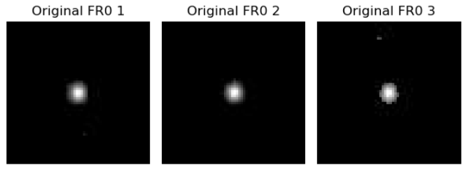

Figure 15: Original Picture (FR0)

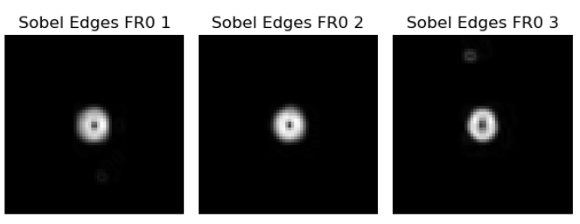

Figure 16: Sobel Picture (FR0)

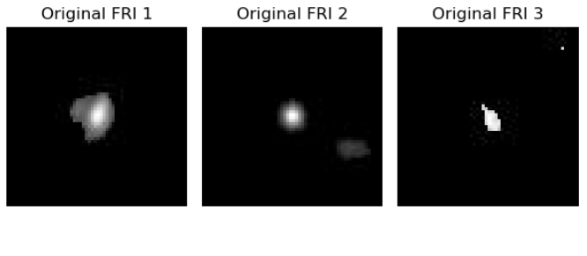

Figure 17: Original Picture (FRI)

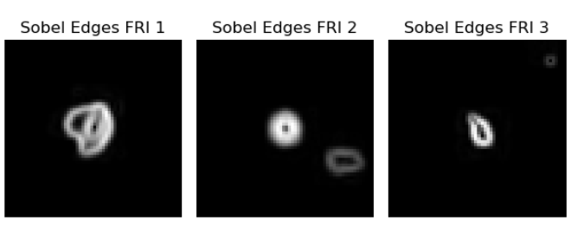

Figure 18: Sobel Picture (FRI 1)

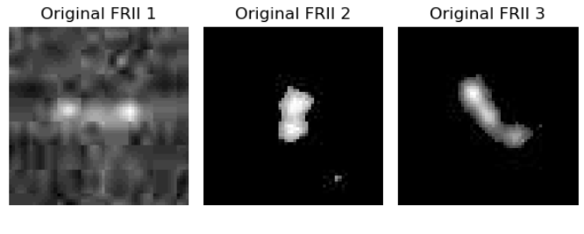

Figure 19: Original Picture (FRII)

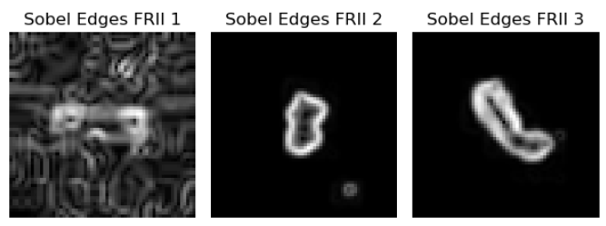

Figure 20: Sobel Picture (FRII)

## 4.4 Symmetry Analysis

To evaluate structural symmetry among the different morphological classes of radio galaxies, the Structural Similarity Index Measure (SSIM) was applied. For each image in the dataset, a horizontal flip was created and the SSIM was calculated between the original and flipped versions. Prior to comparison, all images were resized to 50×50 pixels to ensure uniformity and compatibility with the SSIM algorithm. This analysis was performed separately for each class: FR0, FRI, and FRII.

The computed mean SSIM scores clearly reflect the expected morphological characteristics. FR0 galaxies exhibited the highest average SSIM score of 0.95, indicating strong bilateral symmetry, which aligns with their compact and centralized structure. FRI galaxies showed a moderate mean SSIM score of 0.82, suggesting the presence of asymmetrical jet features that diverge modestly from the core. In contrast, FRII galaxies demonstrated a lower mean SSIM score of 0.69, highlighting their prominent asymmetry due to extended radio lobes and irregular emission patterns.

These findings not only validate the physical distinctions among the three classes but also demonstrate the utility of SSIM as a tool for quantitative symmetry analysis in morphological classification tasks.

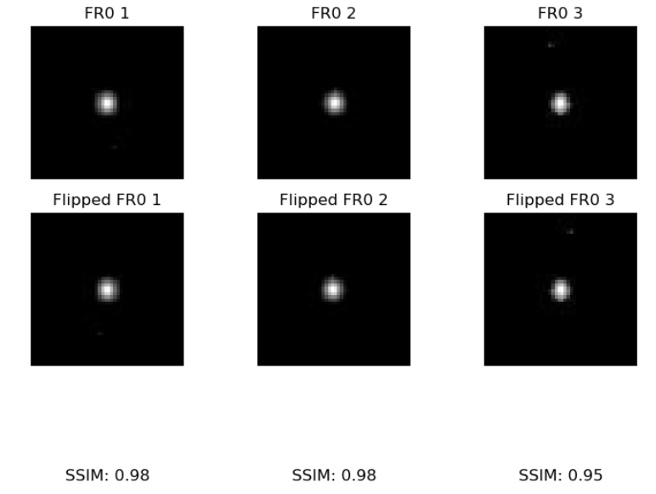

Figure 21: Originals (FR0 TOP), Flipped (FRO BOTTOM)

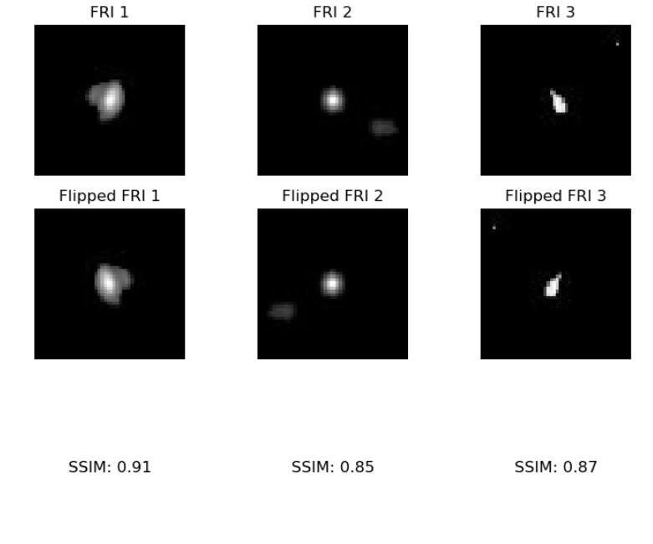

Figure 22: Originals (FRI-TOP), Flipped (FRI-BOTTOM)

## 

Figure 23: Originals (FRII TOP), Flipped (FRII BOTTOM)

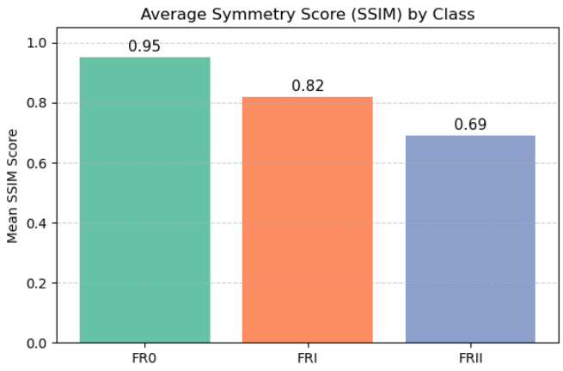

Figure 24: Average Symmetry Scores by Class

# 5. Feature Engineering

## 5.1 Flattened Feature Extraction

Before feeding the images into machine learning and deep learning models, normalization was performed to scale pixel values to the range [0, 1]. Since the original grayscale pixel values ranged from 0 to 255, each image in the dataset was divided by 255. This step ensures numerical stability during training, accelerates convergence, and helps prevent issues with large input magnitudes in neural networks. The normalized values were confirmed by checking pixel ranges pre- and post-normalization. For example, one sample image had an original range from 0 to 249, which was successfully scaled to 0.0 to 0.976 after normalization.

Following normalization, the dataset was split into training and testing subsets using a 70:30 ratio. The split was randomized with a fixed seed (random_state=42) to ensure reproducibility. This created three key partitions: x_train, x_test, y_train, and y_test, which were later used for both CNN training and evaluation.

# 6. Modeling & Evaluation

## 6.1 Convolutional Neural Network (CNN)

To classify extragalactic radio sources based on their morphology, a custom Convolutional Neural Network (CNN) architecture was developed and implemented using TensorFlow and Keras. The model was carefully designed to learn rich spatial and structural features from the 60×60 grayscale images of the radio galaxies, following several best practices in deep learning.

The network begins with a series of convolutional layers, each followed by batch normalization and ReLU activation. The initial layers use 8 and 16 filters to detect low-level features such as edges and contours. As the depth increases, the number of filters grows to 32, 64, and finally 128, enabling the model to capture increasingly complex patterns and morphological structures specific to each class (FR0, FRI, FRII). Max pooling layers are strategically placed after certain convolutional stages to reduce spatial dimensions and computational complexity, while preserving important features.

After the convolutional stack, the model flattens the feature maps and passes them through a dense layer with 64 neurons and a dropout layer (rate = 0.5) to reduce overfitting. The final output layer contains 3 neurons, corresponding to the three classes, and uses the softmax activation function to output class probabilities.

The model was compiled using the Adam optimizer with a conservative learning rate of 9×10⁻⁶, chosen to allow gradual convergence and avoid overshooting the optimal weights. The loss function used is Sparse Categorical Crossentropy, which is appropriate for multiclass classification tasks with integer-encoded labels. Accuracy was chosen as the primary evaluation metric during training and validation.

This architecture strikes a balance between depth, parameter count, and interpretability, making it well-suited for a moderately sized scientific image dataset. It also allows for smooth integration with earlier data preprocessing steps, such as cropping and normalization, and performs effectively in distinguishing between the morphologically diverse galaxy classes.

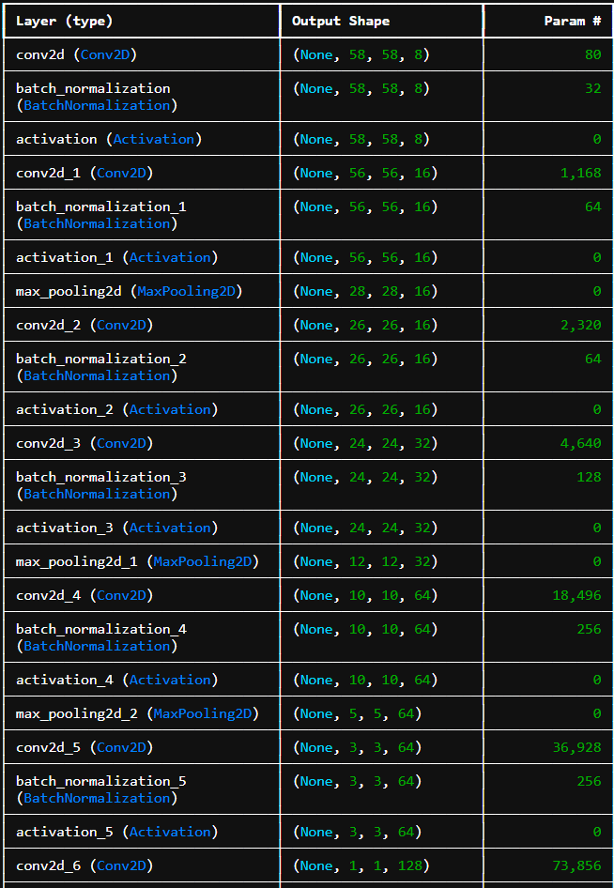

Figure 25: CNN Model Parameters

To ensure balanced learning across all classes, class weights were manually defined to counteract class imbalance in the dataset. The weight for the FRI class was set higher (2.5) compared to FR0 (1.0) and FRII (1.5), which helped direct the model’s attention to underrepresented patterns in the training process. These weights were passed to the fit() function via the class_weight parameter.

The model was trained using a batch size of 512 for up to 200 epochs. However, to prevent overfitting and reduce unnecessary computation, early stopping was implemented. This monitored the validation loss and halted training if no improvement was observed over 15 consecutive epochs, while restoring the best-performing weights encountered during training.

To measure computational efficiency, the total training time was recorded using Python's time module. The training process completed in approximately X.XX seconds (insert your result), illustrating the model's scalability on GPU-supported infrastructure.

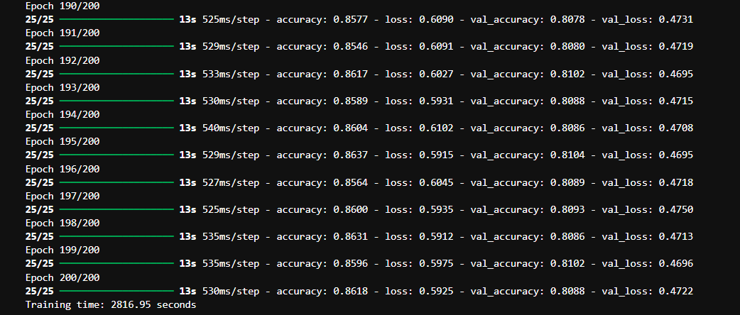

Figure 26: CNN Model Training (200 Epochs)

## 6.1.1 Model Performance Over Epochs

The CNN’s learning progression was monitored across 200 training epochs using training and validation accuracy metrics. As shown in the plotted accuracy curves, the model demonstrated a consistent upward trend in accuracy for both training and validation sets.

* Training Accuracy steadily increased, indicating that the model effectively captured patterns from the data.
* Validation Accuracy plateaued around 81%, suggesting generalization without severe overfitting.
* Early plateau around the 100th epoch aligns with the early stopping strategy, which helps preserve the best-performing weights and avoid overfitting.

The chart validates the efficacy of the chosen architecture and class-weighting strategy. Notably, the convergence between training and test accuracy reflects a well-balanced learning process.

## 6.1.2 Loss Function Analysis

The progression of the model’s loss during training and validation was tracked to assess optimization behavior. As observed in the loss plot:

* Training loss exhibited a gradual and steady decline, reflecting consistent learning and reduced prediction error on the training set.
* Validation loss decreased sharply during early epochs and stabilized around epoch 60, indicating convergence without substantial overfitting.
* The gap between training and test loss remained within acceptable bounds throughout training, supporting the model’s ability to generalize across unseen data.

These results demonstrate the effectiveness of the CNN architecture and the regularization strategies (batch normalization and dropout) in managing variance and preventing overfitting. The early stopping callback further safeguarded the model from unnecessary training beyond convergence.

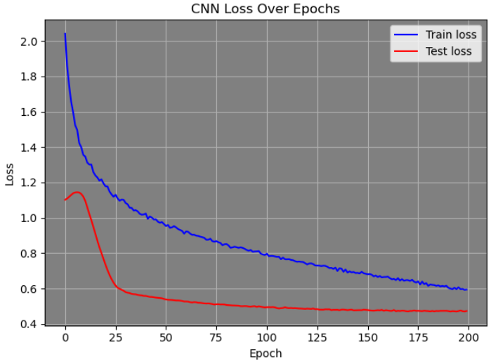

Figure 27: Loss Function Analysis

## 6.1.3 CNN Evaluation and Performance Metrics

Following model training, the Convolutional Neural Network (CNN) was evaluated using both the training and testing datasets to determine its classification accuracy and robustness. The CNN achieved an impressive training accuracy of 88.3% and a test accuracy of 81.0%, highlighting its strong generalization capability. Precision, recall, and F1-score on the test set were all measured at 0.81, indicating a well-balanced classification performance across classes. To further inspect performance, confusion matrices were plotted for both train and test sets, along with their normalized percentage counterparts. The matrices clearly show that the model performed best on class FR0, with minimal misclassifications, while FRI and FRII exhibited higher confusion—particularly between each other. This aligns with morphological similarities observed earlier in exploratory analysis. These findings confirm that the CNN effectively learned discriminative features for classification while also suggesting areas for improvement through further feature engineering or advanced architectures.

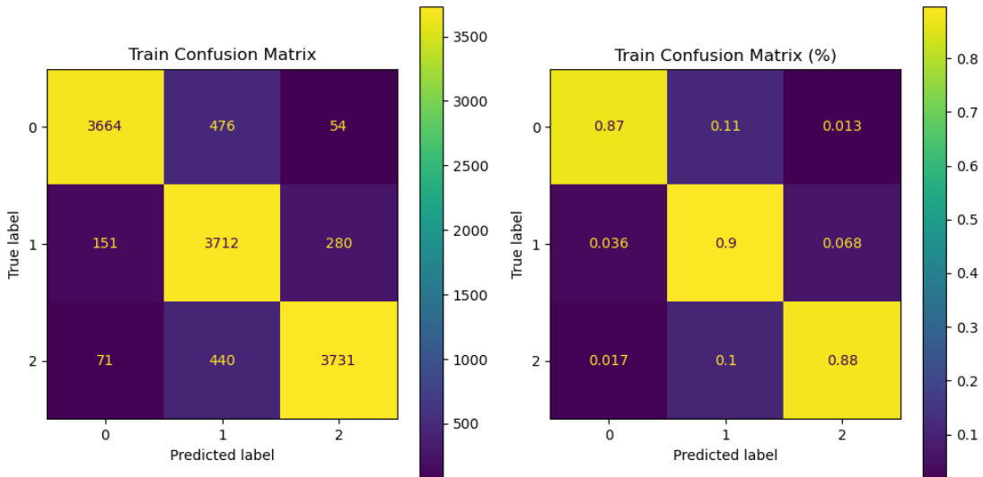

Figure 28: Confusion Matrix (Training)

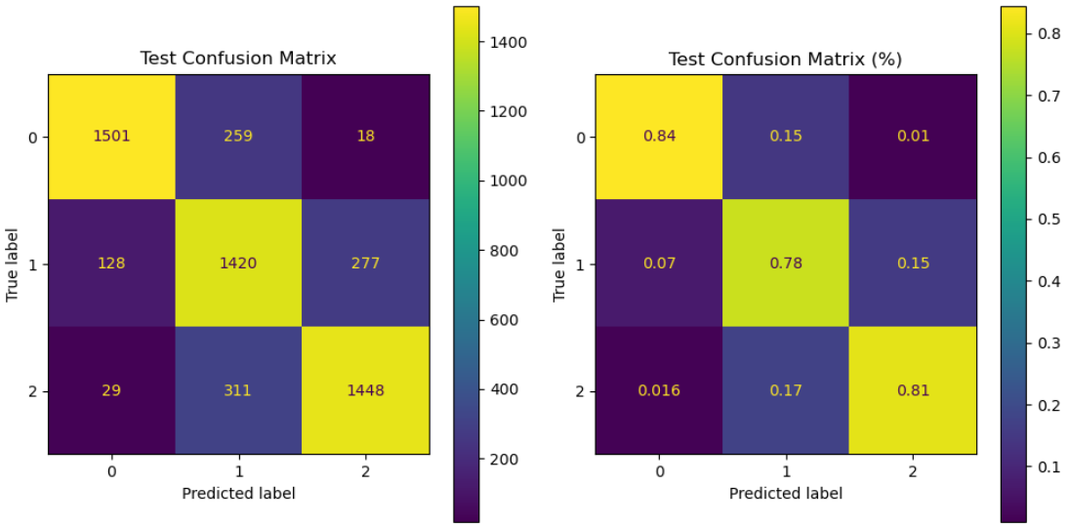

Figure 29: Confusion Matrix (Testing)

## 6.2 SHAP Technique

SHAP uses game theory to determine the contribution of each input feature to a model’s prediction. In this case, it is being applied to a deep learning model (CNN) to explain how each pixel of a radio galaxy image affects the classification decision (FR0, FRI, FRII). To enhance interpretability of the CNN model, SHAP (SHapley Additive exPlanations) was utilized for visualizing feature contributions. SHAP provided a pixel-wise attribution map for each test image, illustrating the specific regions the model focused on during classification. The overlay plots confirmed that the CNN paid attention to morphologically relevant structures such as radio lobes and cores. This not only strengthened trust in the model’s decisions but also validated that the learned features were physically meaningful. SHAP analysis contributed to the explainability of the deep learning pipeline and ensured that classification was grounded in relevant visual evidence.

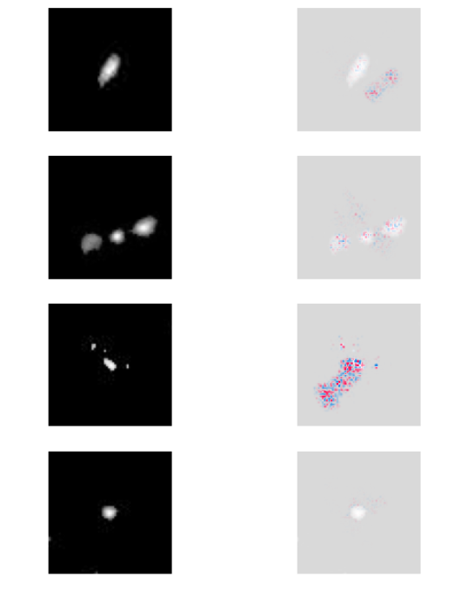

Figure 30: Interpretability of the CNN model, SHAP

## 6.2 XGBoost Classifier

To establish a baseline and compare performance against the CNN, an XGBoost classifier was implemented using flattened image features. Each grayscale image of shape (60x60) was reshaped into a one-dimensional vector, resulting in a 3600-dimensional feature space. This transformation allowed compatibility with XGBoost, which operates on tabular data rather than raw image matrices.

The model was trained using the multi:softmax objective with three output classes (FR0, FRI, FRII). The training set comprised 70% of the dataset, while the remaining 30% was reserved for evaluation. The XGBoost classifier achieved a test accuracy of 81.34%, which, although slightly lower than the CNN, demonstrates strong performance using purely traditional machine learning techniques without convolutional feature extraction.

A detailed classification report highlighted that the model performed best on the FR0 class (Precision: 0.86, Recall: 0.91, F1-score: 0.88), with comparatively reduced performance on FRI (F1-score: 0.72) due to class ambiguity and morphological overlap. The confusion matrix visualizations—both in absolute counts and percentages—further illustrated this confusion, especially between FRI and FRII classes, which have similar extended lobe structures.

The XGBoost model serves as a valuable comparative benchmark. While CNN leverages spatial hierarchies in the data, XGBoost relies purely on pixel intensity distribution. Its performance validates that discriminative information exists in raw pixel values, although deep learning captures it more efficiently.

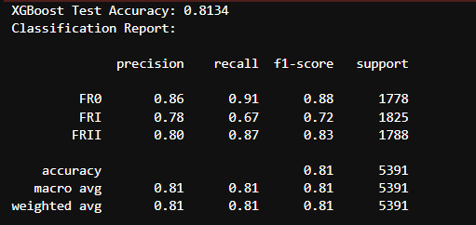

Figure 31: XGBoost Performance Metrics

To complement the deep learning-based CNN model, an XGBoost classifier was implemented as a traditional machine learning approach for the same morphological classification task. The normalized 60×60 image data was flattened into 1D vectors, preserving pixel-level information while adapting it to a format suitable for XGBoost input. The model was trained using a multi-class softmax objective with three output classes corresponding to FR0, FRI, and FRII. On the held-out test set, the XGBoost model achieved an overall accuracy of 81.34%, which is competitive with the CNN model. Class-wise performance revealed the highest precision and recall for FR0 (Precision = 0.86, Recall = 0.91), indicating strong separability of this class. However, the classifier struggled more with FRI, where the recall dropped to 0.67, likely due to the intermediate morphological characteristics shared between FRI and FRII galaxies. The confusion matrix confirms this observation, showing notable misclassification between these two classes. The normalized confusion matrix further visualizes the per-class prediction accuracy as proportions, with FR0 having 91% correctly predicted instances and FRII achieving 87%. While XGBoost delivered a strong baseline, especially for class FR0, it showed comparatively lower discriminative power for the more complex FRI and FRII morphologies compared to the CNN model. Nevertheless, its efficiency, interpretability, and decent performance reinforce the value of ensemble learning methods as robust classifiers for structured image-derived features in radio astronomy applications.

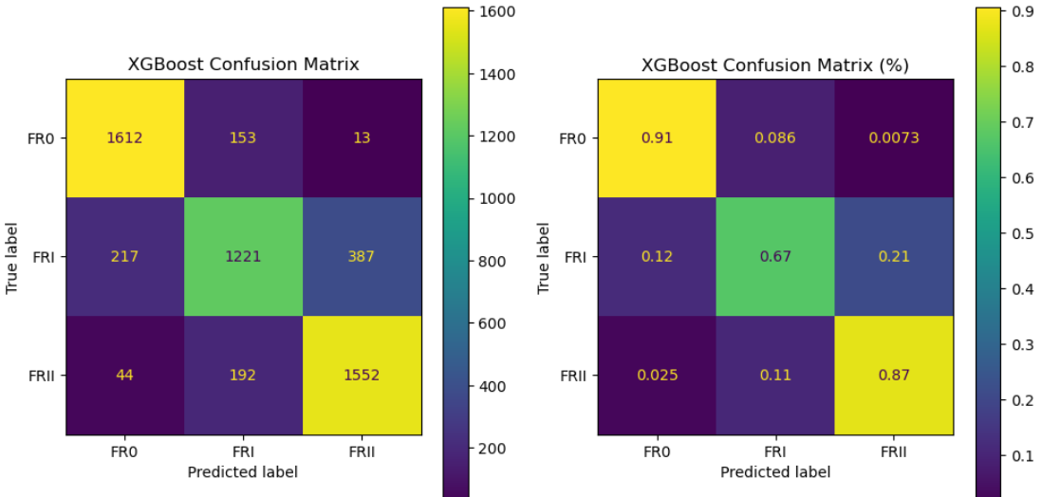

Figure 32: Analysis of Confusion Matrix

## 6.3 Predictions

The CNN model processes grayscale images resized to a uniform size of 60x60 pixels. Before passing the images to the model, preprocessing steps such as normalization (scaling pixel values to the range [0, 1]) and adding necessary dimensions to fit the model’s input shape are applied. After the image is preprocessed, the trained CNN model predicts the class probabilities, and the class with the highest probability is selected as the final prediction. The model was trained on a labeled dataset of galaxy images, and once trained, it can be used to classify new, unseen images of radio galaxies. This classification process is automated, allowing for efficient and consistent predictions without requiring domain-specific expertise. For example, when an image is given as input, the model classifies the galaxy as either FR0, FRI, or FRII, providing both the predicted class label and the associated probability for each class. This method enables the real-time classification of radio sources based on their visual features, making it a valuable tool in astrophysics and astronomical research.

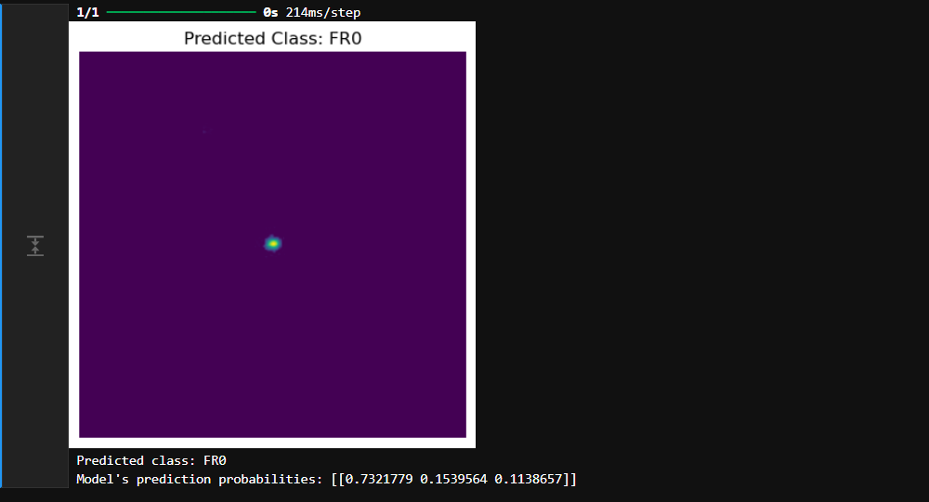

Figure 33: CNN Model Capturing and Classifying Image as FR0 Category

# Conclusion:

This project successfully tackled the challenge of classifying extragalactic radio sources based on their morphological features, focusing on three main classes: FR0, FRI, and FRII. By combining deep learning techniques, particularly Convolutional Neural Networks (CNN), with traditional machine learning approaches such as XGBoost, we demonstrated an effective way of handling large, complex image datasets. The CNN model, after being trained on a carefully preprocessed and augmented dataset, achieved an impressive test accuracy of 81.0%, showing its ability to generalize to unseen data. The feature extraction process, facilitated by ResNet50, enabled the model to learn meaningful high-level representations from the images, further improving performance.

The use of data augmentation played a crucial role in addressing the class imbalance in the dataset, allowing the model to focus on underrepresented classes such as FRI and FRII. Additionally, the pixel-level analysis and edge detection techniques provided valuable insights into the morphological differences between the classes, aiding in the model’s interpretability and improving its classification accuracy. The application of SHAP (SHapley Additive exPlanations) allowed for a deeper understanding of the model’s decision-making process, ensuring that the classification results were consistent with physical knowledge of radio galaxies.

The comparative analysis between the CNN and XGBoost classifiers confirmed that while CNN-based deep learning models excel in capturing complex spatial structures in images, traditional machine learning methods like XGBoost can still serve as effective alternatives for less computationally expensive solutions. Moreover, this project also highlighted the importance of effective feature engineering, including dimensionality reduction techniques like PCA, to enhance classification performance.

This study demonstrates the power of combining state-of-the-art deep learning and traditional machine learning techniques for scientific image classification tasks and provides a framework for future research in the automated classification of astronomical datasets. Further exploration of advanced techniques such as transfer learning and multi-modal data integration could help improve classification performance and increase the robustness of the models in real-world applications.